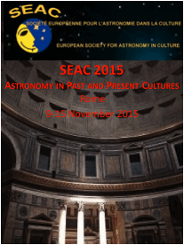
REGISTRATION FORM SEAC 2015
Astronomy in Past and Present Cultures
Rome, 9-13 November 2015

Academic Title (Prof, Dr, etc)
Name (First NAME, Middle, LAST SURNAME) *

Affiliation *
Gender *
Age *

Address *
City *
ZIP / Postal Code *
Country *
Phone/Mobile
Email *
Accompanying Persons NAMES

PLEASE TRANSFER AT
account no. 636769/09 in ASSOCIAZIONE CULTURALE CESAR name
CARIPARMA – CRÉDIT AGRICOLE branch 616 RM-AG. 39
IBAN IT53D0623005089000063676909
BIC/SWIFT CRPPIT2P616
ABI 06230
CAB 0589

Payment Transfer ______EUROS by IBAN

Payment Transfer ______EUROS by SWIFT

OR PAY BY PAYPAL Payment ______EUROS (http://www.brera.inaf.it/SEAC2015/registration.htm)

Vegetarian? *

Any Other Message to the LOC

Signed __________________

You must fill in all fields marked by *.
PLEASE NAME THE FILE: YOUR SURNAME-NAME-REGISTRATION-FORM-SEAC2013
PLEASE RETURN YOUR FILE TO vitofrancesco.polcaro@iaps.inaf.it

